Project: Diamond Prices

# Step 1: Understanding the Model

*Answer the following questions:*

1. According to the model, if a diamond is 1 carat heavier than another with the same cut, how much more should I expect to pay? Why?

The given linear model is Price = -5269 + 8413 x Carat + 158.1 x Cut + 454 x Clarity.

If a diamond is taken which is 1 carat heavier than another diamond with same cut and clarity, for example :

Price1 = -5269 + 8413 x 1.0+ 158.1 x 2+ 454 x2 = 4368.2

Price2 = -5269 + 8413 x 2.0 + 158.1 x 2+ 454 x2 = 12781.2

then according to the above linear model, we should expect to $8413 more.

1. If you were interested in a 1.5 carat diamond with a **Very Good** cut (represented by a 3 in the model) and a **VS2** clarity rating (represented by a 5 in the model), how much would the model predict you should pay for it?

For the equation :

Price1 = -5269 + 8413 x 1.5 + 158.1 x 3 + 454 x 5 = 4368.2

The model has predicted to pay $10,094.8

# Step 2: Visualize the Data

1. 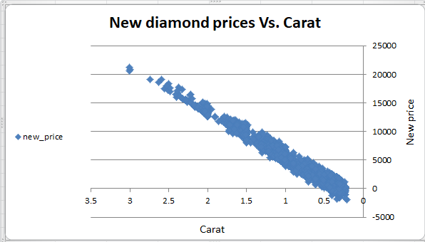Plot 1 - Plot the data for the diamonds in the database, with carat on the x-axis and price on the y-axis.
2. Plot 2 - Plot the data for the diamonds for which you are predicting prices with carat on the x-axis and predicted price on the y-axis.
   * **Note**: You can also plot both sets of data on the same chart in different colors.

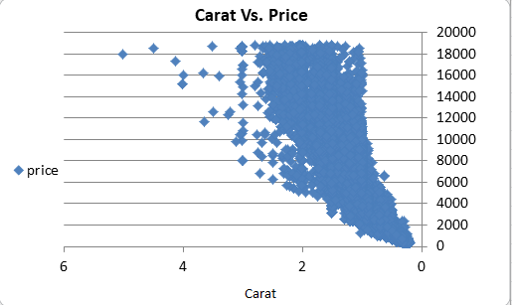

1. What strikes you about this comparison? After seeing this plot, do you feel confident in the model’s ability to predict prices?

For the new diamond :

- The new diamonds dataset has a positive correlation between price and carat.

- some cases the price is negative which indicates that it is not correct price . Subsequently, the use of linear regression model for finding prices not always good idea .

For the old diamond :

- The old diamond prices and carat did not have a strong correlation.

- There are other factors like cut and clarity which affects the price of diamonds.

# Step 3: Make a Recommendation

*Answer the following questions:*

1. What price do you recommend the jewelry company to bid? Please explain how you arrived at that number.

Summing up all the predicted prices and taking 70% of it gives the price $8,213,466.